

**UNIVERSITY OF PETROLEUM AND ENERGY STUDIES**

**School of Computer** **Science**

**2020-21**

**GRAPHICS AND ANIMATION TOOLS LAB**

**Faculty: Dr. DURGANSH SHARMA**

**Assistant Professor**

**Department of Cybernetics.**

**School of Computer Science, UPES**

**Submitted By:**

**Name- Manushi Kapoor**

**Roll no-R100217037**

**Batch-B1**

**Semester- 7**

**Course-B.tech. CSE-OSOS**

**Sap Id- 500062100**

EXPERIMENT 6

**Aim** :- Design of 3D Hut using Blender.

**Objective** :- To Design a 3D Hut using features of Blender 2.8 .

**STEPS TO MAKE DESIGN A 3D TEXT:-**

1. Open Blender workspace delete the existing cube.
2. Take 2 mesh objects – Cylinder and cone.
3. Cylinder forms the lower part of hut, while cone forms the upper part.
4. Set property as Fur for desired look.
5. Take a plane surface and position it beneath cylinder to form the land.
6. Apply dirt texture on it by going to properties and adding an image of dirt in shading area.

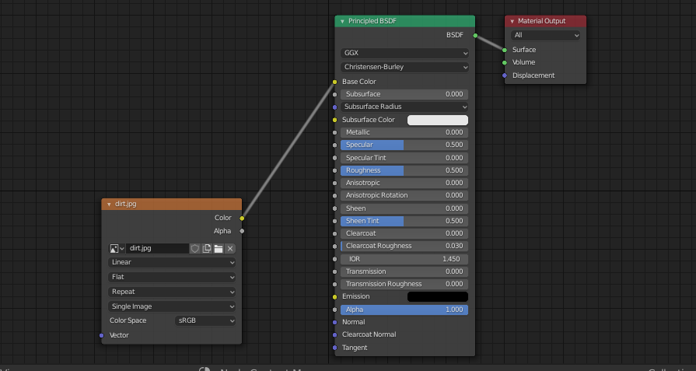

1. Take tree curves and position them at the back of the hut.
2. Extrude the edges of land a bit upwards.
3. Select a face of cylinder and delete it to make it look like the entrance of the hut.
4. Apply color to Hut and trees.
5. Final result is shown below –

